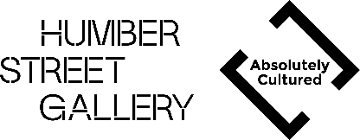
INTER_CHANGE 2024/25 APPLICATION FORM

CONTACT
Name:
Address:
Email:
Contact number:

ARTISTIC PRACTICE

Please answer the below questions in no more than 250 words (per answer)

Describe your artistic practice including relevant experiences and education (if applicable):

What are the current challenges you are facing in your practice and how do you think INTER_CHANGE will help you overcome them:

What cultural material have you seen, read, watched or listened to recently which has inspired or challenged you:

As part of INTER_CHANGE you will be required to run a skills sharing session or workshop. What are your ideas for what this might be:

ACCESS
We want to ensure everyone working with us feels as comfortable as possible. There is the option below to disclose anything you would like us to know at this stage. This can be anything you feel is relevant, especially that which might help us better accommodate your participation in the programme. Additionally, if you wish to request any adjustments to the application process, we are more than happy to accommodate that. Get in touch with lauren.wilson@absolutelycultured.co.uk.

Is there anything we can do to better facilitate your involvement in the programme:

SUPPORTING DOCUMENTS

Please attach the following documents when you return your application

- Artist CV
- Portfolio of up to 5 images of your work
- Access Rider (if applicable)

Please return this application form to lauren.wilson@absolutelycultured.co.uk by 22nd September

